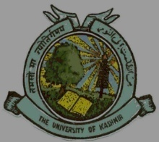
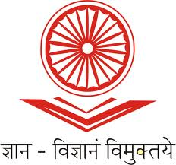
UGC-Human Resource Development Centre
(Formerly Academic Staff College)

University of Kashmir
Hazratbal, Srinagar, Kashmir, 190006

No: HRDC/KU/2021 Dated: 20/09/2021

Extension Notice

In continuation to our Circular No. HRDC/KU/2021 dated 08/09/2021 regarding the conduct of 86th Faculty Induction Programme for a period of three weeks in online mode, the date of submission of the online as well as offline application forms is extended up to 27th of September, 2021. Pertinently the Programme will commence from 30th of September, 2021 instead of 21st September, 2021.

Signed.
Prof. Mushtaq Ahmad Darzi
Director

Copy to:
- Director, IT & SS, University of Kashmir for uploading the circular on the University website.
- All Heads/ Directors of the Departments/Centers of the University of Kashmir.
- PRO, University of Kashmir for publication in local English and Urdu Dailies preferably Greater Kashmir.

