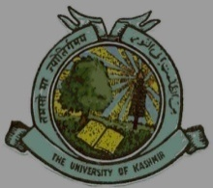
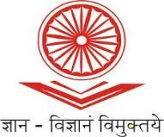
UGC-Human Resource Development Centre
(Formerly Academic Staff College)

UNIVERSITY OF KASHMIR
Hazratbal, Srinagar, Kashmir, 190006

No: HRDC/KU/2022/264
Dated: 03/08/2022

Circular

Refresher Course in Teacher Education

UGC - Human Resource Development Centre, University of Kashmir is going to conduct Refresher Course in Teacher Education w.e.f. August 18th, 2022 in online mode via Google Meet Platform which was earlier scheduled from August 03rd, 2022.

Faculty from Higher Education Institutions (HEIs) like Universities, Colleges, and N.I.Ts, are eligible for the said course. The eligible faculty who are interested to attend the course can register online at :
https://docs.google.com/forms/d/e/1FAIpQLSdwdnCB-uvAHvzqoAdWnMLJHi_tlP1_bxBkqIg0Pb9cRncTSw/viewform?usp=sf_link
The participants are also requested to submit duly filled in enclosed application form (downloaded from: http://hrdc.uok.edu.in/Main/List.aspx?Type=Download ) along with the proof of depositing fee at the office of HRDC, University of Kashmir by or before August 16th, 2022 either in person or a soft copy by email to asc@kashmiruniversity.ac.in . Due to limited capacity, admission will be on first-come-first-serve basis.

The participants can pay their registration fee of Rs. 1000/- to:

Account Name: Director, Academic Staff College, University of Kashmir, Srinagar
Account Number: 0007010100000807
IFSC Code: JAKA0NASEEM
Bank Name and Branch: J&K Bank, Hazratbal, Srinagar

Sd/-
Prof. Mushtaq Ahmad Darzi
Director

