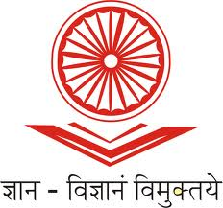
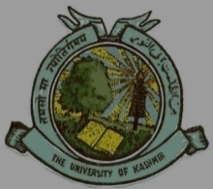
UGC-Human Resource Development Centre
(Formerly Academic Staff College)

University of Kashmir
Hazratbal, Srinagar, Kashmir, 190006

No: KU2022/HRDC/1773
Dated: 13-10-2022
Circular

This is for the information of all concerned that the UGC-Human Resource Development Centre, University of Kashmir, Srinagar is going to organize Online Webinars as per the following schedule. Participation is invited from the Faculty and Research Scholars working in different higher education institutions by registering with the following link latest by 19-10-2022.
S.No. | Details of Resource Persons | Date | Time | Topic | Links
01. | Prof. Uma Kanjilal,  Pro Vice-Chancellor, IGNOU, New Delhi | 20-10-2022 | 2:00 pm  to  3:30 pm | OERs, MOOCS & Open Education | https://docs.google.com/forms/d/e/1FAIpQLScNCs_BqikYvwXMlfYqNiWtd-d03HvOZwqhtGIqEebZWU-12w/viewform?usp=sf_link
02. | Prof. Shahid Rasool  Dean, Department of Convergent Journalism, School of Media Studies, Central University of Kashmir | 25-10-2022 | 10:00 am  to  11:30 am | MOOCS Development | https://docs.google.com/forms/d/e/1FAIpQLScNCs_BqikYvwXMlfYqNiWtd-d03HvOZwqhtGIqEebZWU-12w/viewform?usp=sf_link
03. | Prof. M. Ishaq Geer  Director, Centre for Career Planning Counselling, University of Kashmir, Srinagar | 28-10-2022 | 10:00 am  to  11:30 am | National Education Policy | https://docs.google.com/forms/d/e/1FAIpQLScNCs_BqikYvwXMlfYqNiWtd-d03HvOZwqhtGIqEebZWU-12w/viewform?usp=sf_link

Due to limited intake capacity, only 40 participants shall be registered in each webinar on first-come-first-serve basis and participants shall receive the e-certificates for having attended the webinar.

Sd/-
Prof. Mushtaq Ahmad Darzi
Director

Copy to:
- All Deans/Heads/ Directors of the Schools/Departments/Centers of the University of Kashmir.
- Director, IT & SS, University of Kashmir for uploading the circular on the University website.

