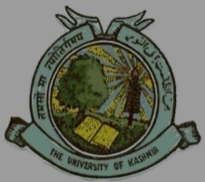
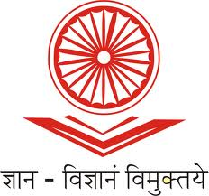
UGC-Human Resource Development Centre
(Formerly Academic Staff College)

University of Kashmir
Hazratbal, Srinagar, Kashmir, 190006

No: KU2022/HRDC/ Dated: 24/08/2022

Circular

Webinar on “National Education Policy (NEP) 2020-Towards a Multidisciplinary Approach”

UGC - Human Resource Development Centre, University of Kashmir is going to conduct a Webinar on “National Education Policy (NEP) 2020- Towards a Multidisciplinary Approach “on August 30th, 2022 (Tuesday) from 2.00 p.m. in online mode using Google Meet Platform.

Dr. Anisa Jan, Dean Students Welfare, Islamic University of Science and Technology, Awantipora will deliver the lecture via Google Meet platform. The webinar will help the faculty to visualize the functionality of NEP across HEIs. Interested faculty members can register through the link mentioned here under:
https://docs.google.com/forms/d/e/1FAIpQLSe-4wefWU_iGTz6kzXAYQiF0kX8SfVitVhGXN5Of3VNal107A/viewform?usp=sf_link

Due to limited intake capacity admission shall be given on a first-come-first-serve basis to the first 70 participants only. Registration will be free of cost and the participants will receive an e-certificate for having attended the webinar.

Sd/-
Prof. Mushtaq Ahmad Darzi
Director

Copy to:
- All Deans/Heads/ Directors of the Schools/Departments/Centers of the University of Kashmir.
- Director, IT & SS, University of Kashmir for uploading the circular on the University website.

