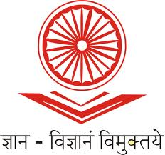
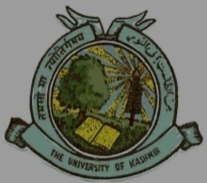
UGC-Human Resource Development Centre
(Formerly Academic Staff College)

University of Kashmir
Hazratbal, Srinagar, Kashmir, 190006

No: HRDC/KU/2022 Dated: 22/07/2022
Notice

This is for the information of all concerned that the UGC-Human Resource Development Centre, University of Kashmir, Srinagar is going to organize Online Webinars on National Education Policy (NEP) – 2020 as per the following schedule. Participation is invited from the Faculty and Research Scholars working in different higher education institutions by registering with the following links latest by 24-07-2022.
S.No. | Details of Resource Persons | Date | Time | Topic | Links
01. | Prof. Vani Nikhil Laturkar  Director, School of Commerce, Management Studies, S.R.T.M University, Nanded, Maharashtra | 25-07-2022 | 11:30 am  to  1:00 pm | NEP & its role in boosting citizenship among Commerce & Management | https://docs.google.com/forms/d/e/1FAIpQLSeZ58HSotnXeSv5UXAlo_2eV-f_yxhNR9Tynw29emyoaMjGaw/viewform?usp=sf_link
02. | Prof. A.M. Shah  Former Dean Academic Affairs,  University of Kashmir | 29-07-2022 | 10:00 am  to  11:30 am | Challenges in implementation of NEP 2020 | https://docs.google.com/forms/d/e/1FAIpQLSfNq64lvCIFHDOoV3y2YgyD-2iNmWkJIsvZnYChqo3ACfRUpQ/viewform?usp=sf_link

Due to limited intake capacity, only 50 participants shall be registered in each webinar on first-come-first-serve basis and participants shall receive the e-certificates for having attended the webinar.
Sd/-
Prof. Mushtaq Ahmad Darzi
Director

Copy to:-

- P.S. to Vice-Chancellor, University of Kashmir for kind information of Honorable Vice Chancellor.
- Registrar, University of Kashmir for kind information.
- Director, HRDC Guru Nanak Dev University, Amritsar.
- Director IT&SS, University of Kashmir with the request to kindly upload the same on University Website.

