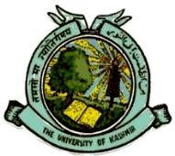
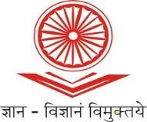
UGC-Human Resource Development Centre
(Formerly Academic Staff College)

UNIVERSITY OF KASHMIR
Hazratbal, Srinagar, Kashmir, 190006

No: KU2022-HRDC-1788
Dated: 16/11/2022

Circular

Refresher Course in Gender & Development Studies

(Interdisciplinary)

UGC - Human Resource Development Centre, University of Kashmir is going to conduct Refresher Course in Gender & Development Studies w.e.f. December 13th, 2022 in Hybrid (online/offline) Mode.

Faculty from Higher Education Institutions (HEIs) like Universities, Colleges, and N.I.Ts, are eligible for the said course. The eligible faculty who are interested to attend the course can register online at :

https://docs.google.com/forms/d/e/1FAIpQLScDSFgpzwQzgZr1vtqarK5aR5cRIUX5Fx6KT-QCOklh25erkA/viewform?usp=sf_link

The participants are also requested to submit duly filled in enclosed application form (downloaded from: http://hrdc.uok.edu.in/Main/List.aspx?Type=Download ) along with the proof of depositing fee at the office of HRDC, University of Kashmir by or before December 10th, 2022 either in person or a soft copy by email to asc@kashmiruniversity.ac.in . Due to limited capacity, admission will be on first-come-first-serve basis.

The participants can pay their registration fee of Rs. 1000/- to:

Account Name: Director, Academic Staff College, University of Kashmir, Srinagar
Account Number: 0007010100000807
IFSC Code: JAKA0NASEEM
Bank Name and Branch: J&K Bank, Hazratbal, Srinagar

Copy to:
Sd/-
Prof. Mushtaq Ahmad Darzi Director

    - All Deans/Heads/ Directors of the Schools/Departments/Centers of the University of Kashmir.
    - Director, IT & SS, University of Kashmir for uploading the circular on the University website.

PRO, University of Kashmir for publication in one local English Daily preferably Greater Kashmir.

File.

