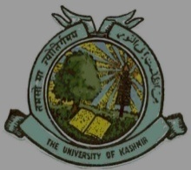
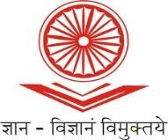
UGC-Human Resource Development Centre
(Formerly Academic Staff College)

UNIVERSITY OF KASHMIR
Hazratbal, Srinagar, Kashmir, 190006

No: KU2022/HRDC/1766
Dated: 29/09/2022

Circular

88th Guru Dakshta Faculty Induction Programme

UGC - Human Resource Development Centre, University of Kashmir is going to conduct one month 88th Guru Dakshta Faculty Induction Programme w.e.f. October 25th, 2022 in online mode via Google Meet Platform which was earlier scheduled from September 30th, 2022.

Newly appointed faculty members working on substantive basis in all streams from Universities, Colleges, N.I.Ts, and other Higher Education Institutions are eligible for the said course. The faculty members who are interested to attend the course are desired to register online at:
https://docs.google.com/forms/d/e/1FAIpQLSeGqpgtTG016TOgM2lHCTLuCFCIq24vhKJsn388vLGGB5Axuw/viewform?usp=sf_link

The desirous participants are impressed to pay their registration fee of Rs. 1000/- to:

Account Name: Director, Academic Staff College, University of Kashmir, Srinagar
Account Number: 0007010100000807
IFSC Code: JAKA0NASEEM
Bank Name and Branch: J&K Bank, Hazratbal, Srinagar

The participants are also requested to submit duly filled in enclosed application form (downloaded from: http://hrdc.uok.edu.in/Main/List.aspx?Type=Download ) along with the proof of depositing fee at the office of HRDC, University of Kashmir by or before October 20th, 2022 either in person or a soft copy by email to asc@kashmiruniversity.ac.in . Further the selected participants are required to submit the relieving order from their respective institutions before commencement of the course.

Due to limited intake capacity admissions will be given on first-come-first-serve basis.

Sd/-
Prof. Mushtaq Ahmad Darzi
Director

Copy to:

- All Deans/Heads/Directors of the Schools/Departments/Centers of the University of Kashmir.
- Director IT&SS, University of Kashmir for uploading the Circular on the University Website.

